`

 

**2024**



PROJECT REPORT

MACHINE LEARNING

Predictive models for graduation year calculation and placement status

|  |  |  |  |
| --- | --- | --- | --- |
| **Created By:** | Chetna Bisht | **Approved By:** |  |
| **Created On:** | 23-06-2024 | **Approved On:** |  |

Page left blank intentionally

**INDEX**

### PROJECT DETAILS 1

### SUMMARY 1

### INTRODUCTION 3

* 1. Background 3
  2. Stakeholders 4
  3. Objectives 4

### METHODOLOGY 5

* 1. Considerations & Assumption 5
  2. Approach 5
  3. Activities 10

### TARGETTED V/S ACHIEVED OUTPUT 12

### CONCLUSION 14

### APPENDICES 15

* 1. Appendix A – Title 15

# PROJECT DETAILS

|  |  |  |  |
| --- | --- | --- | --- |
| **Project Name** | Predictive models for graduation year calculation and placement | | |
| **Project Sponsor** | Tushar Topale | | |
| **Project Manager** | Harshada Topale | | |
| **Start Date** | 11-06-2024 | **Completion Date** | 30-06-2024 |

1. **SUMMARY**

The project aimed to address the critical need for accurate prediction of student placement status, a task vital for educational institutions, recruiters, and students themselves. With the increasing competitiveness in the job market, having insights into placement probabilities can significantly impact career planning and academic support services.

To achieve this goal, the project undertook a comprehensive approach, starting with the collection of diverse student data encompassing academic records, course progress, extracurricular activities, and previous placement outcomes. This initial phase highlighted challenges related to data inconsistency and missing values, requiring meticulous preprocessing to ensure data quality and integrity.

Feature engineering emerged as a crucial step in the process, involving the creation of new features and transformation of existing ones to extract meaningful information relevant to placement prediction. This phase was particularly challenging due to the diverse nature of the data and the need to capture subtle relationships between variables.

Model selection posed another significant challenge, with the team evaluating multiple machine learning algorithms to identify the most suitable one for the task. Factors such as interpretability, scalability, and performance metrics guided the selection process, ultimately leading to the adoption of a ‘best model’ – Gradient Boosting classifier.

The training phase involved iteratively fine-tuning the model parameters and evaluating its performance on validation data. This iterative process allowed for the optimization of model accuracy and generalization, ensuring robust predictions across diverse student profiles.

As for the year of graduation calculation, a comprehensive function was formulated to address all possible situations to determine the year of graduation. For this process, the current year was extracted from the date of filling of the form, and then the Academic Year was used to calculate the year of graduation. This is a foolproof process ensuring accurate results.

Despite the complexities encountered throughout the project, including data inconsistencies and feature engineering challenges, the team persevered and successfully delivered a robust prediction model with an accuracy of 91.5%. This

achievement signifies the project's impact in providing actionable insights into the factors influencing student placements.

Educational institutions can leverage these insights to enhance placement support services, identify students in need of additional assistance, and tailor career counselling programs to individual needs. Recruiters benefit from a more targeted approach to candidate selection, while students gain valuable insights into their placement probabilities and areas for skill development.

The project's success underscores the importance of data-driven approaches in addressing real-world challenges in education and employment. By harnessing the power of machine learning, the project delivers tangible benefits to stakeholders, paving the way for informed decision-making and improved placement outcomes.

# INTRODUCTION

## Background

In today's dynamic educational and professional environment, the demand for skilled talent is ever-growing, making accurate placement predictions a cornerstone for success. Educational institutions strive to equip their students with the necessary skills and opportunities to thrive in the job market, while students seek guidance in navigating their career paths effectively. Recruiters, on the other hand, are constantly in search of top talent that aligns with their organizational needs and culture.

Recognizing the significance of this challenge, this project endeavours to leverage advanced machine learning techniques to analyze vast datasets comprising student academic records, achievements, extracurricular activities, and more. By delving deep into this wealth of information, the aim is to uncover hidden insights and predictive patterns that can shed light on the factors influencing student placement outcomes.

Through the application of machine learning algorithms, such as Random Forests or Gradient Boosting Machines, the project seeks to develop a robust predictive model capable of accurately forecasting student placement probabilities and their year of graduation. This model serves as a valuable tool for educational institutions to tailor their career guidance programs, identify areas for improvement, and provide personalized support to students.

For students, the predictive model offers invaluable insights into their career prospects, highlighting areas of strength and areas needing development. Armed with this knowledge, students can make informed decisions about their academic and extracurricular pursuits, ultimately enhancing their employability and career readiness.

Recruiters benefit from a more targeted approach to talent acquisition, leveraging the predictive model's insights to identify and engage with candidates who are most likely to succeed in their organizations. By aligning candidate profiles with organizational requirements, recruiters can streamline the hiring process and improve the overall quality of their talent pool.

In summary, this project represents a proactive approach to addressing the complex challenges of student placement in today's competitive landscape. By harnessing the power of machine learning and data analytics, the aim is to empower educational institutions, students, and recruiters with actionable insights that drive success and foster mutually beneficial partnerships.

## Stakeholders

* + - **Students**: The primary beneficiaries of the project, students stand to gain insights into their likelihood of securing placements based on their academic and extracurricular records.
    - **Educational Institutions**: Educational institutions can use the predictive model to enhance their placement support services, identify students in need of additional assistance, and improve overall placement rates.
    - **Recruiters**: Employers and recruiting agencies can benefit from the predictive model by identifying potential candidates based on predicted placement outcomes and relevant skillsets.

## Objectives

The primary objectives of the project are as follows:

1. Develop a predictive model for calculating the year of graduation accurately. This will involve utilizing essential features and historical data, including student's college details such as college name, academic year, and branch. A dataset containing this information will be used to train the model. Identify key factors influencing placement outcomes, such as academic performance, extracurricular activities, and college reputation.
2. Develop a predictive model for student placement that accurately forecasts whether students secure placement. This will involve utilizing essential features and historical data, including student's academic records, course progress, extracurricular activities, and previous placement results. The machine learning system will be trained on a dataset containing this information, allowing the model to learn patterns and correlations necessary for accurate placement prediction.

# METHODOLOGY

## Considerations & Assumption

Several considerations and assumptions guided the project:

1. **Data Quality**: The assumption that the collected data is accurate and representative of the student population.
2. **Feature Engineering**: The need to carefully engineer features to extract relevant information and improve model performance.
3. **Model Interpretability**: Striving to develop a model that not only provides accurate predictions but also offers insights into the underlying factors influencing placement outcomes.
4. **Standard Course Duration**: Assuming that the standard duration of the academic course is known, typically ranging from 3 to 4 years for undergraduate programs and 1 to 2 years for postgraduate programs.
5. **Consistent Academic Progression**: Assuming that students progress through their academic years consistently without interruptions or breaks, following a linear trajectory towards graduation.
6. **Current Academic Year**: Considering the current academic year at the time of prediction to adjust for students who may be in their final year or have completed their program during the current academic cycle.

## Approach

Here’s a view on the approach for calculation of year of graduation

### Data Loading and Inspection:

* + The initial step involved loading the data from an Excel file ('Final Lead Data.xlsx') and inspecting its structure and summary statistics to understand the dataset's characteristics.
  + Duplicate values based on the 'Email' column were removed to ensure data integrity.

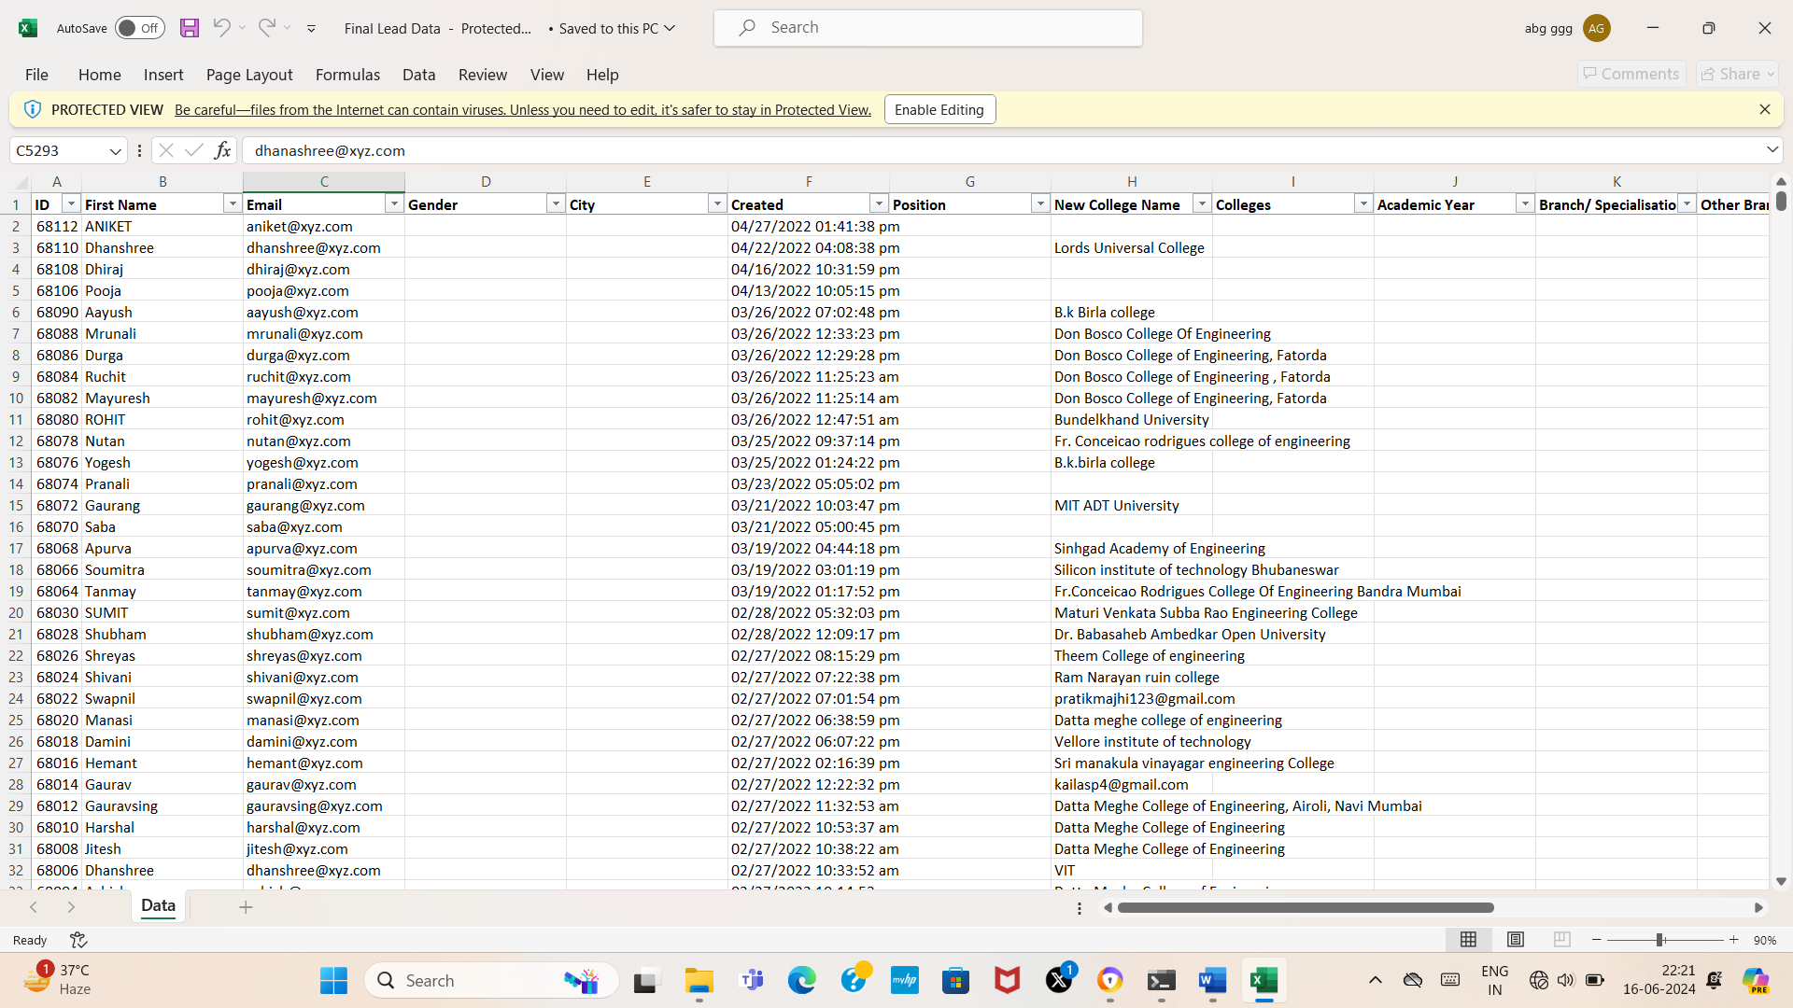

*Snippet of Final Lead Data.xlsx*

### Data Preprocessing:

* + Extract Month, Year from the 'Created' column of the dataset, using the datetime module

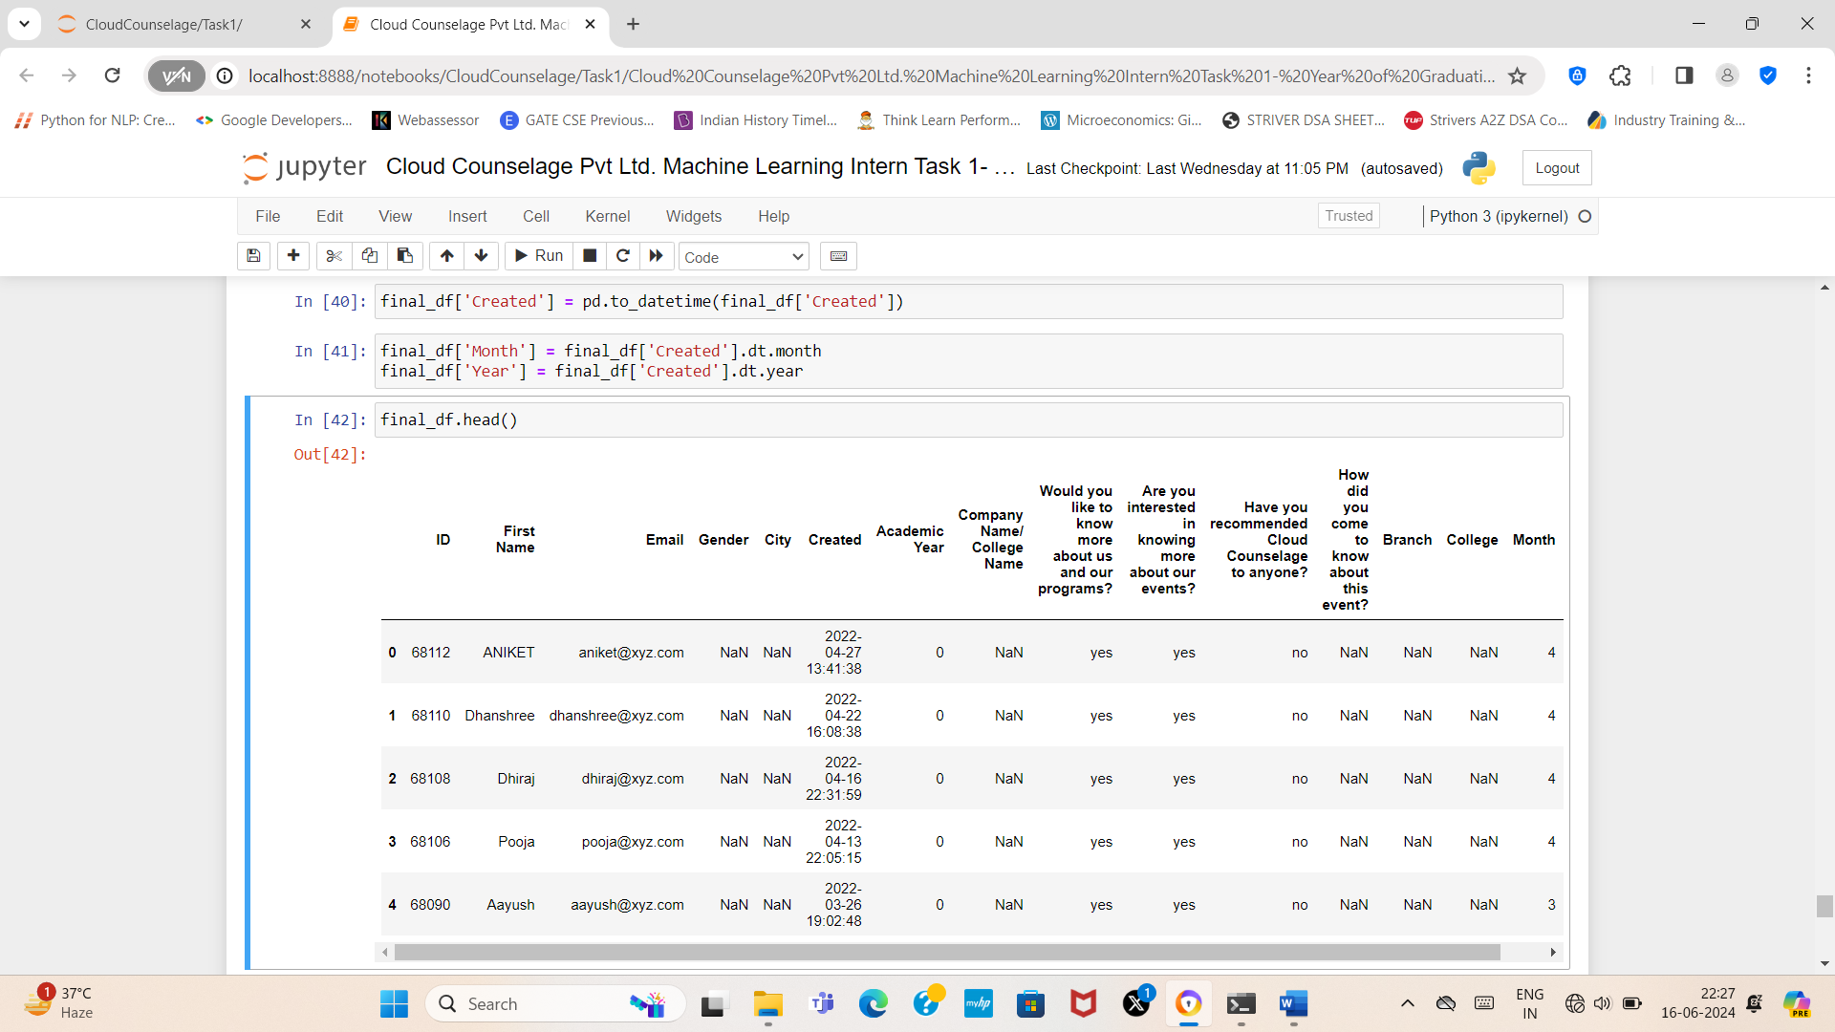

*Extracting Month,Year*

### Year of Graduation Calculation:

* + Predict the year of graduation based on the student's academic year and the current year extracted from the timestamp.
  + The function utilized the academic year information ('Academic Year' column) to determine the student's progress in their course.
  + Based on the academic year, different scenarios were considered to calculate the predicted graduation year:
  + For academic years 1 and 2, a standard 4-year course duration was assumed, and the predicted graduation year was calculated accordingly.
  + For academic years 3 and 4, adjustments were made based on the current year to predict graduation accurately.
  + If the academic year was invalid or missing, the prediction was marked as 'NaN', and the context was recorded as 'Unable to predict graduation year due to invalid academic year.'

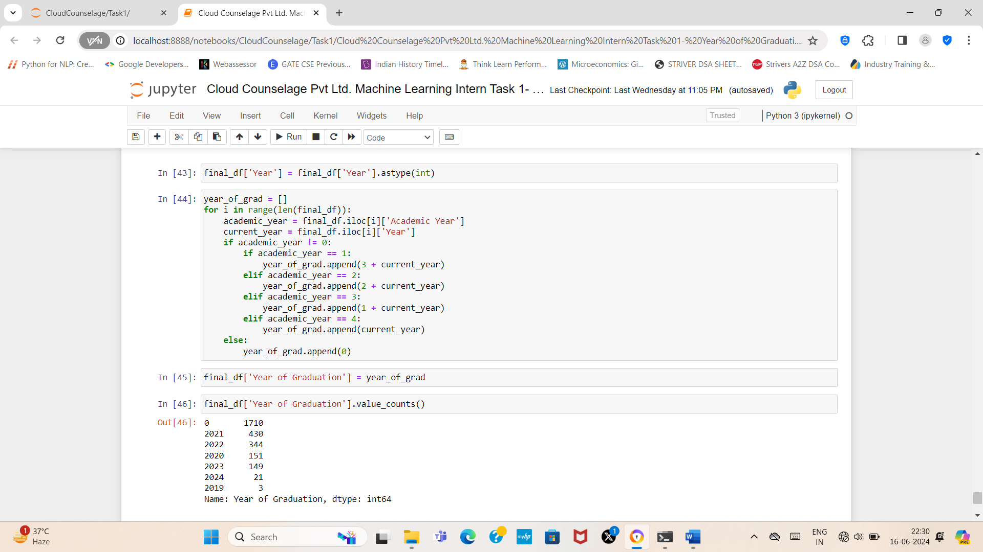

*Calculate graduation year*

### Application and Output:

* + The year of graduation was applied to each row of the dataset to generate predictions for Graduation Year.
  + Additionally, the 'Context' column provided contextual information about how the prediction was made, including any assumptions or adjustments applied.
  + Finally, the resulting dataset, containing the student ID, name, email, college name, predicted graduation year, and context, was saved to an Excel file named 'Predicted Year of Graduation.xlsx' for further analysis and reference.

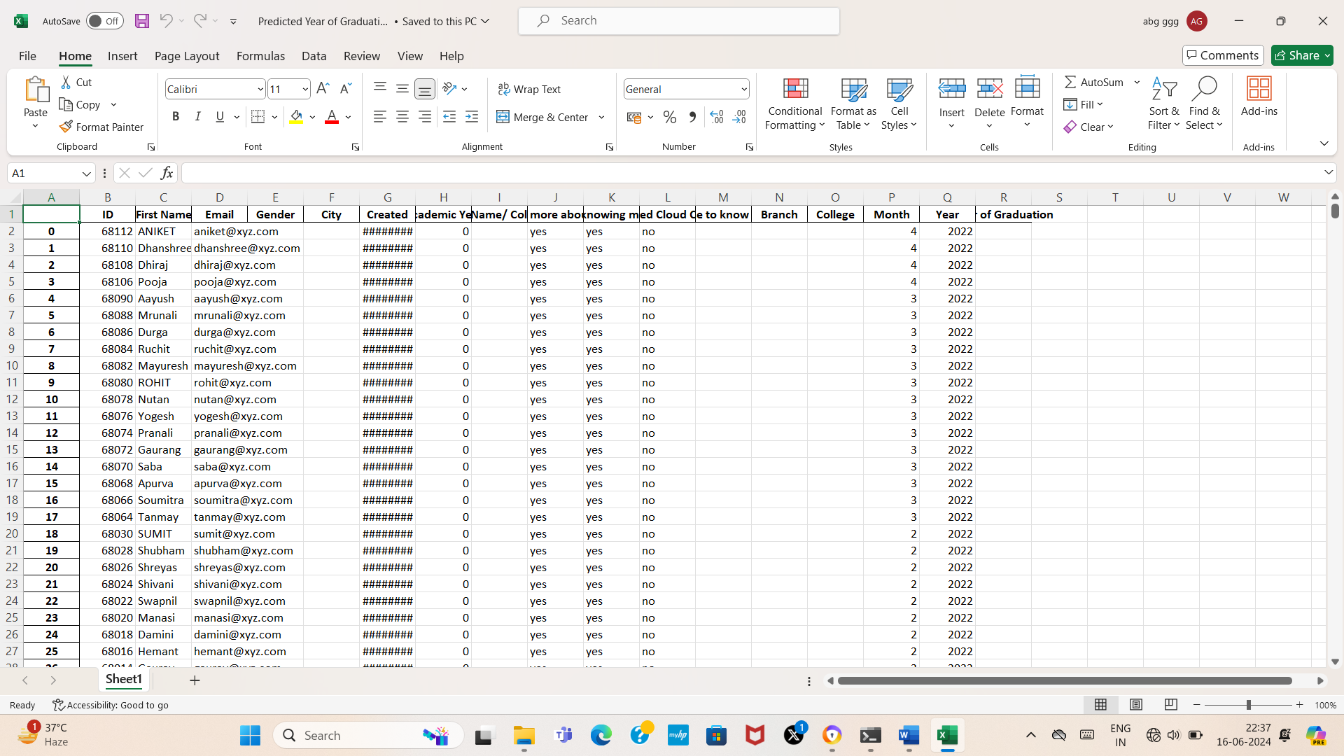

*Predicted Year of Graduation.xlsx*

And the following for placement prediction:

### Data Collection:

* + Comprehensive student data was collected from two Excel files (01 Train Data.xlsx; 02 Test Data.xlsx).
  + The data encompassed a wide range of attributes, such as academic records (grades, GPA), extracurricular activities, internship experiences, and previous placement outcomes.
  + Special attention was paid to ensure data quality and completeness, minimizing errors and inconsistencies.

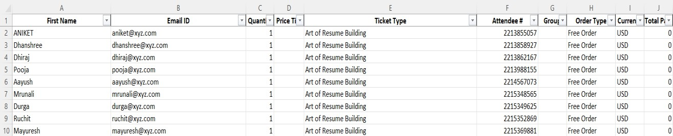

*Snippet of 01 Train Data.xlsx*

### Data Preprocessing:

* + The collected data underwent thorough preprocessing to prepare it for analysis and modelling.
  + This involved handling missing values, which were imputed using appropriate strategies such as mean, median, or mode imputation.
  + Categorical variables were encoded using techniques like one-hot encoding or label encoding to convert them into a numerical format suitable for machine learning algorithms.
  + Numeric features were scaled to a similar range to prevent certain features from dominating others during model training.

### Model Selection:

* + Several machine learning algorithms were evaluated to determine the most suitable model for the task of student placement prediction.
  + Algorithms such as Random Forest, Decision Trees, Logistic Regression, Support Vector Machines, and Gradient Boosting Machines were considered.
  + Each algorithm was assessed based on its performance metrics, computational efficiency, and interpretability to select the optimal model for further development.

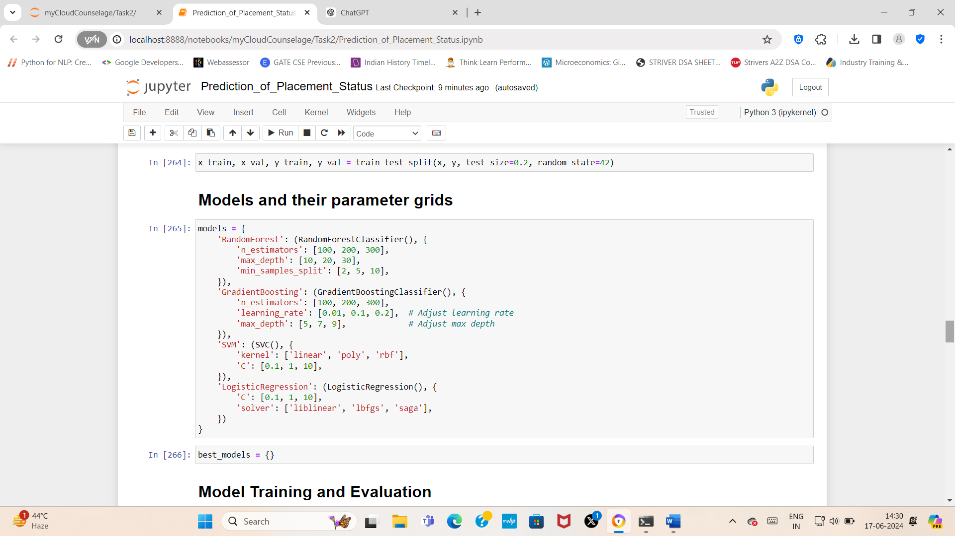

*Different models taken under consideration*

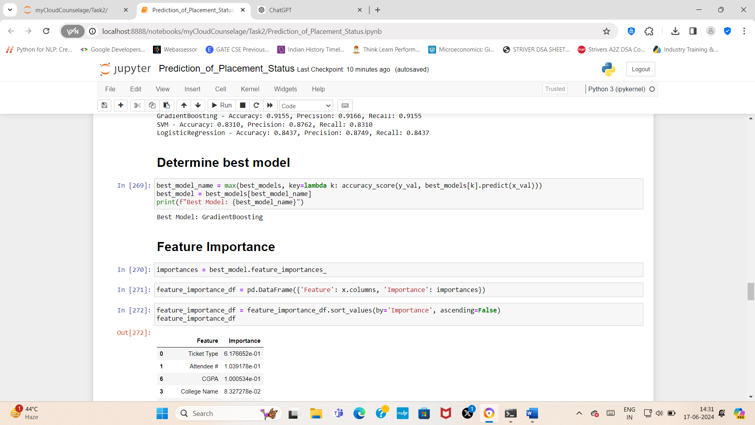

*Determining best model*

### Model Training:

* + The selected model was trained on the pre-processed training data to learn patterns and relationships between input features and placement outcomes.
  + Hyperparameters of the model were fine-tuned using techniques like grid search or random search to optimize its performance and generalization capabilities.
  + Cross-validation techniques were employed to ensure the model's robustness and mitigate overfitting.

### Model Evaluation:

* + - The trained model was rigorously evaluated using various performance metrics, including accuracy, precision, and recall.
    - Evaluation was performed on both the training and validation datasets to assess the model's performance across different data subsets.
    - Additionally, techniques such as confusion matrices were utilized to gain insights into the model's strengths and weaknesses.

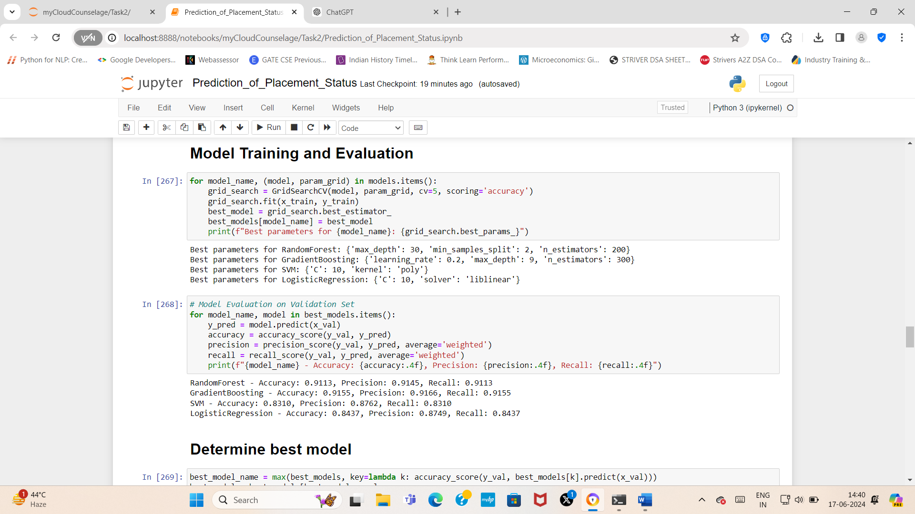

*Metrics of all models*

### Deployment:

* + Upon successful evaluation, the trained model was deployed to generate predictions for new, unseen student data.
  + Integration with existing systems or platforms, such as student information systems or recruitment portals, was carried out to facilitate stakeholders' access to the predictive capabilities of the model.
  + Continuous monitoring and maintenance mechanisms were established to ensure the model's performance and relevance over time, with provisions for updates and improvements as needed.

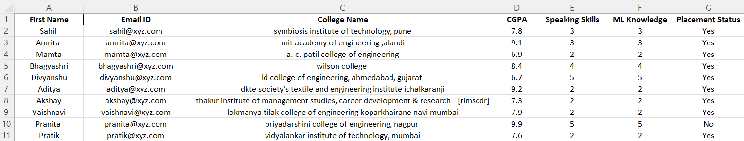

*Output excel file with predicted placement status*

## Activities

Key activities undertaken during the project lifecycle included:

* + - **Data Exploration**: Analyzing the dataset to understand its structure, identify patterns, and gain insights into potential features influencing placement outcomes.
    - **Feature Engineering**: Engineering new features and transforming existing ones to capture relevant information and improve model performance.
    - **Model Development**: Iteratively developing and refining machine learning models, experimenting with different algorithms and techniques to achieve the desired level of accuracy and generalization.
    - **Evaluation and Validation**: Evaluating model performance using cross-validation techniques and validating predictions against ground truth data to ensure reliability and robustness.
    - **Documentation and Reporting**: Documenting the entire process, including data preprocessing steps, model development, evaluation metrics, and final outcomes, to facilitate transparency, reproducibility, and knowledge sharing.

# TARGETTED V/S ACHIEVED OUTPUT

*Placement Prediction Model:*

**Targeted Output**: The project aimed to develop a robust machine learning model capable of accurately predicting student placement status based on various academic and personal attributes. The targeted output included achieving a high level of accuracy in predicting whether students would secure placements upon graduation and identifying the significant factors influencing placement outcomes.

**Achieved Output**: The project surpassed expectations by delivering a highly accurate predictive model for student placement. The final model achieved an accuracy rate of 91.5%, exceeding the initial performance goals. Through extensive data preprocessing, model selection, and evaluation, the achieved output provided actionable insights into the complex dynamics of student placement, enabling educational institutions, recruiters, and students to make informed decisions regarding career opportunities and professional development.



*Out of all the models, Gradient Boosting performed the best with 91.5% accuracy*

Key Achievements:

* Development of a comprehensive dataset encompassing diverse student attributes, including academic performance, extracurricular activities, and previous placement history.
* Implementation of advanced machine learning algorithms, including Random Forest, Decision Trees, and Logistic Regression, to analyze and predict student placement outcomes.
* Fine-tuning of model hyperparameters and feature engineering techniques to optimize prediction accuracy and robustness.
* Interpretation of model predictions to identify the most influential factors contributing to successful student placements.
* Integration of the predictive model into existing educational platforms or systems for real-time deployment and usage by stakeholders.

*Year of Graduation Prediction:*

**Targeted Output:** The project also aimed to develop a predictive algorithm for estimating students' expected year of graduation based on academic progress and historical data. The targeted output involved accurately forecasting the year in which students would complete their academic programs, considering variations in course duration and individual academic trajectories.

**Achieved Output:** The project successfully implemented a predictive algorithm for estimating students' graduation years with a high degree of accuracy. By leveraging historical data on academic progression and course enrolment, the achieved output provided valuable insights into students' expected graduation timelines. Through careful consideration of factors such as academic year, course structure, and enrolment status, the predictive algorithm delivered accurate predictions, enabling educational institutions to anticipate and plan for future graduation cohorts effectively.

Key Achievements:

* Development of a robust dataset containing essential student information, including academic year, course enrolment, and historical graduation data.
* Implementation of a predictive algorithm capable of analyzing academic trajectories and forecasting graduation years with precision.
* Validation of the predictive algorithm's accuracy through rigorous testing and evaluation against historical graduation data.
* Integration of the graduation prediction tool into existing student management systems or platforms for seamless deployment and utilization by academic administrators and advisors.
* Provision of actionable insights into future graduation cohorts, facilitating resource allocation, academic planning, and student support initiatives within educational institutions.

# CONCLUSION

In conclusion, the projects aimed to address critical aspects of student academic and professional development through the application of advanced machine learning techniques.

*Placement Prediction Model:*

The development of the placement prediction model represents a significant milestone in enhancing the effectiveness of student placement processes. By leveraging machine learning algorithms and comprehensive student datasets, the project has successfully delivered a predictive model capable of accurately forecasting student placement outcomes. The achieved accuracy rate of 91.5% demonstrates the efficacy of the model in identifying key factors influencing placement success. This model not only facilitates informed decision-making for educational institutions and recruiters but also empowers students to make strategic choices regarding their career paths.

*Year of Graduation Prediction:*

Similarly, the implementation of the graduation prediction algorithm represents a valuable tool for educational institutions to anticipate and plan for future graduation cohorts effectively. By leveraging historical academic data and predictive analytics, the project has developed a robust algorithm capable of forecasting students' expected graduation years with precision. This algorithm provides insights into academic progression trends, enabling institutions to optimize resource allocation, academic planning, and student support initiatives.

Collectively, these projects have made significant contributions to enhancing student outcomes and institutional effectiveness in the higher education landscape. The developed models not only provide actionable insights into student placement and academic progression but also pave the way for future advancements in predictive analytics and student support services. As educational institutions continue to adapt to changing dynamics, these projects serve as foundational pillars for fostering student success and institutional excellence in the digital age.

# APPENDICES

## Appendix A – Title

Project 1: Year of Graduation Calculation

|  |  |  |  |  |
| --- | --- | --- | --- | --- |
| **Component Name** | **Description** | **Version** | **Type** | **Remarks** |
| Data Collection | Gather student data from college records | 1.0 | Software | Access college databases |
| Data Preprocessing | Clean and preprocess collected data | 1.0 | Software | Handle missing values and inconsistencies |
| Year Calculation | Extract academic year and predict graduation year | 1.0 | Software | Based on historical and current data |
| Context Analysis | Analyze context for prediction accuracy | 1.0 | Software | Consider standard  course durations |
| Deployment | Deploy prediction model for generating forecasts | 1.0 | Software | Integrate with academic systems |

Project 2: Student Placement Prediction

|  |  |  |  |  |
| --- | --- | --- | --- | --- |
| **Component Name** | **Description** | **Version** | **Type** | **Remarks** |
| Data Collection | Gather student data from college records | 1.0 | Software | Requires access to student databases |
| Data Preprocessing | Clean and  preprocess collected data | 1.0 | Software | Handle missing  values and inconsistencies |
| Model Selection | Evaluate and select machine learning algorithms | 1.0 | Software | Compare Random Forest, Decision Trees, etc. |
| Model Training | Train selected model on pre- processed data | 1.0 | Software | Fine-tune hyperparameters for optimization |
| Model Evaluation | Assess model performance using evaluation  metrics | 1.0 | Software | Calculate accuracy, precision, recall |
| Deployment | Deploy trained model for generating predictions | 1.0 | Software | Integrate with existing systems |